**DAY 4**

**BUILDING DYNAMIC FRONTEND COMPONENTS FOR MY MARKETPLACE[Sofa-Market]**

**"Key Components Built for a Seamless E-Commerce Experience"**

**- Header & Footer for consistent navigation.  
- Product Cards and Details pages for dynamic product data.  
- Shop Now,Cart and Checkout components for seamless shopping.  
- Related Products and Social Sharing to encourage engagement.  
- Toast Notifications for real-time user feedback.**

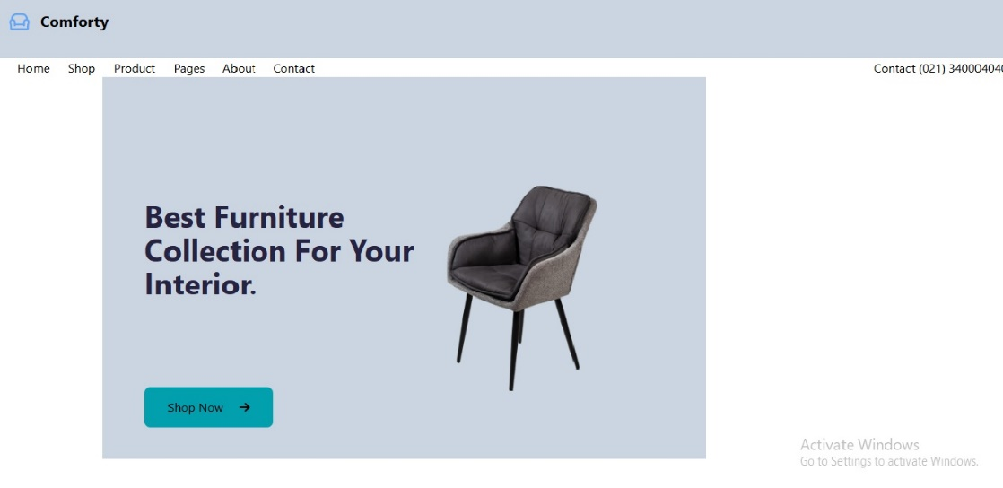k.

